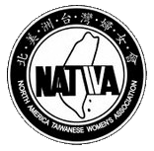
北美洲臺灣婦女會
North America Taiwanese Women’s Association
www.natwa.com

New Chapter Application Form

Submit your proposal to NATWA Secretary — 蘇郁璁 Sophia Su
NATWASECRETARY@gmail.com

Submitter
Name: |  | Date:
Address: | Phone: | Email:
Address: | Fax: | Email:
Per NATWA constitution, Article12(#3),“Any North America local area with tenor more
NATWA members of two-year or longer tenure, upon approval of NATWA, may form a local chapter”, please list the ten(or more) members’names and the year they joined NATWA:
Proposal
Chapter Name:
Establish Date:
Planned Activities(optional):

OfficeUseOnly
Approved by:(Current NATWA President) | Date:
Elected Chapter Officers:(Fill in after new chapter has submitted information)

